Guarantor Paperwork
Tenant Find Property
2021/2022

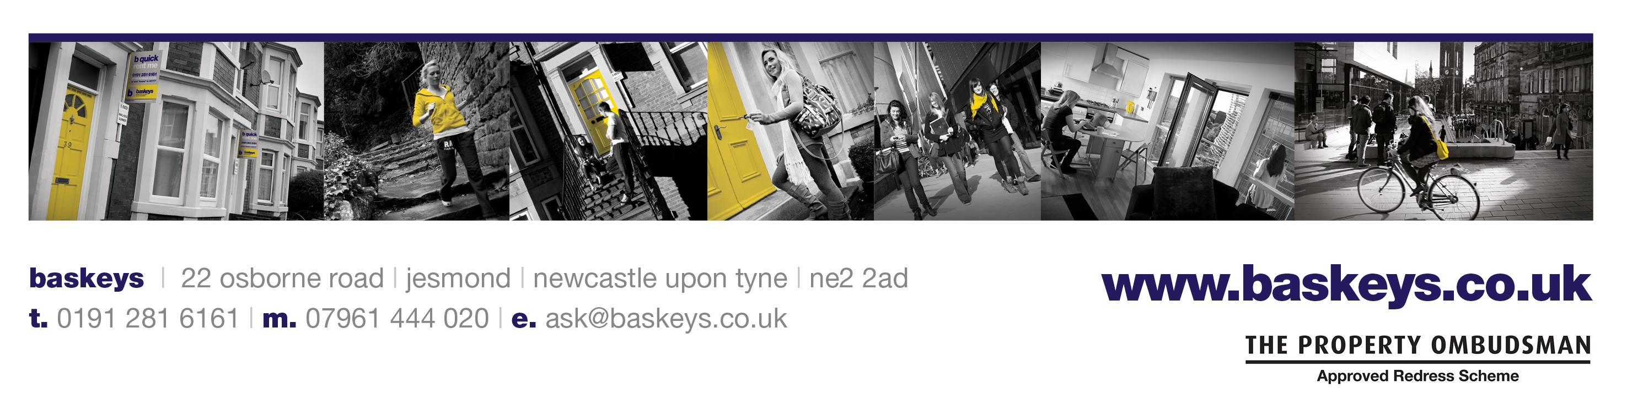

Hello and welcome to baskeys!

We are contacting you as one of our prospective tenants wish to secure a rental property with us soon and they have elected you to be their financial guarantor for the duration of the tenancy. This document contains all the paperwork you need to complete to act as financial guarantor. Please follow the prompt at the left-hand side of your screen to ensure every field is completed. Please read this document thoroughly. If you have any questions about the content of the document, please don’t hesitate to get in touch with our friendly team on 0191 281 6161 or via ask@baskeys.co.uk

It’s important that the full application is completed by the deadline of agreement which is: ______________________

For clarity, a financial guarantor is someone who is prepared to pay rent on your behalf of the tenant should they fail to make payment. The financial guarantor is responsible for covering any arrears during or at the end of your tenancy. If a tenant defaults on a payment, we will contact them first to request that the arrears are settled by them directly but if no payment is forthcoming, we will contact the guarantor for payment.

A financial guarantor must be over the age of 18, live in the UK and work full time. We will also need a copy of their photographic driving license or passport (we cannot accept any other forms of ID). The guarantor does not need to be related to the tenant, as long as they meet the criteria set above. If you want to act as guarantor but do not work full-time or are retired, please contact us on 0191 281 6161 to discuss alternative options.

Please confirm as appropriate:

I have read and understand the criteria set above and can confirm that I meet the criteria and wish
to proceed as guarantor for the applicant.

I have read the criteria set above and unfortunately do not meet the criteria. I am therefore unable
to proceed with the guarantor application.

You will also find a sample copy of our tenancy agreement within this document, please ensure you read this thoroughly prior to completing your application. We are more than happy to answer any queries you may have and so please do not hesitate to contact us! As the landlord for this property is using our tenant find service, the landlord is responsible for the registry of the tenancy deposits. The tenants have been requested to pay their deposits to the landlord directly. We kindly ask therefore that any deposit protection enquiries are made to the landlord directly by the tenants.

the property application

Tenant’s name: ______________________________________________________________________________

Rental property address: _______________________________________________________________________

Start date: ___________________ End date: ____________________ Tenancy term: ________ months

Rent: £_________ per person per week Rent: £__________ per person per calendar month

The tenancy deposit per person is: £____________

your personal details

Title: ___________ Full name (as stated on your passport): ______________________________________________

You will need to provide a copy of your photographic ID as part of your application. We can accept
your driving license or your passport. Please attach a copy of your ID by selecting the paperclip and
uploading an image. You can take a photograph through your device but please ensure the photo is
clear and captures the full document.

Home address: _____________________________________________________________________________

_____________________________________________________________________________

_____________________________________________ Post code: _______________________

How long have you lived at this address? ____________ years and ____________ months
If you have lived at your address for less than 3 years, you will need to provide your previous home address.

Previous home address: _____________________________________________________________________

_____________________________________________________________________

_____________________________________ Post code: ______________________

How long have you lived at this address? ____________ years and ____________ months

Mobile number: _________________________________ Home number: _______________________________

Email: ____________________________________________________ Date of birth: ______________________

Relationship to tenant: _________________________________________________________________________

Occupation: _________________________________ Company name: __________________________________

Company address: ____________________________________________________________________________

____________________________________________________________________________

_____________________________________________ Post code: ______________________
terms and conditions

By signing below I can confirm that I am over the age of 18, that I live in the UK permanently and am in full-time employment or I meet other criteria otherwise agreed in writing with baskeys (subject to their approval). I have reviewed a copy of the tenancy agreement terms and by signing below, I confirm that I will act as the above named tenant’s guarantor for their share of the monthly rent payments in the event that this is not paid by them in accordance with the terms of their Tenancy Agreement.

I understand that in connection with this undertaking the rent is payable on the rent due date as stated in the tenancy agreement which I have read and I understand that should this not be received within 7 days of the due date, the payment can be demanded from me. I also understand that as guarantor I can be held responsible for any damages incurred to the property both during the tenancy and following the end of tenancy inspection that equate to more than the amount of tenancy deposit held. I agree to notify the landlord should there be any change in my employment status or my ability to financially meet this criteria at any point after the signing of this form but I understand that I will remain liable and responsible for any arrears as described above.

I understand that as guarantor all communication with Baskeys and/or the landlord must be made by the named tenant above. I am aware that I can review how baskeys use and store my data in line with their privacy policy by visiting https://www.baskeys.co.uk/privacy-policy.

This guarantee applies to the initial term specified and any extension period in which the tenant remains in occupation at this property. I also confirm that I am financially able to meet this commitment in the event that this becomes necessary and I agree to baskeys carrying out a credit check in my name. By signing below, I agree to the terms stated above and can confirm that I have no previous CCJ, bankruptcy or IVA’s in my name and I have not been served a notice of eviction or currently have a notice held against me.

Signed: ______________________________ Date: __________________

